LATIHAN KONDISI
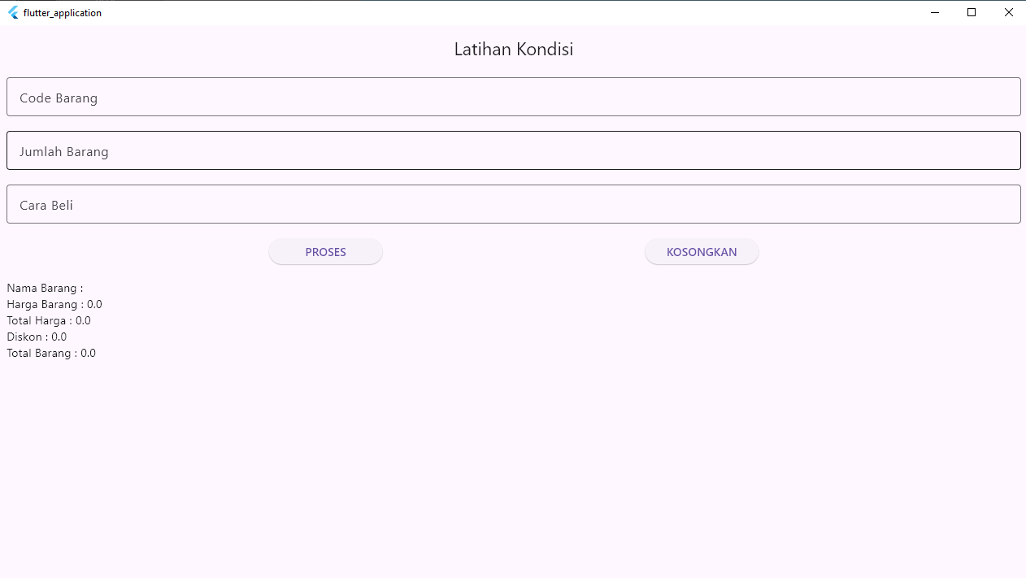

import 'package:flutter/material.dart';

void main(List<String> args) {
runApp(latihan4());
}

class latihan4 extends StatelessWidget {
const latihan4({super.key});

@override
Widget build(BuildContext context) {
return MaterialApp(
home: latihanKondisi(),
debugShowCheckedModeBanner: false,
);
}
}

class latihanKondisi extends StatefulWidget {
const latihanKondisi({super.key});

@override
State<latihanKondisi> createState() => _latihanKondisiState();
}

class _latihanKondisiState extends State<latihanKondisi> {
TextEditingController connCodeBarang = TextEditingController();
TextEditingController connJumlahBarang = TextEditingController();
TextEditingController connCaraBeli = TextEditingController();

String namaBarang = "";
double hargaBarang = 0, totalHarga = 0, diskon = 0, totalBarang = 0;

@override
Widget build(BuildContext context) {
return Scaffold(
appBar: AppBar(title: Center(child: Text('Latihan Kondisi'))),
body: Padding(
padding: const EdgeInsets.all(8.0),
child: Wrap(
runSpacing: 18,
children: [
TextField(
controller: connCodeBarang,
decoration: InputDecoration(
border: OutlineInputBorder(),
labelText: 'Code Barang',
),
),
TextField(
controller: connJumlahBarang,
decoration: InputDecoration(
border: OutlineInputBorder(),
labelText: 'Jumlah Barang',
),
),
TextField(
controller: connCaraBeli,
decoration: InputDecoration(
border: OutlineInputBorder(),
labelText: 'Cara Beli',
),
),
Row(
mainAxisAlignment: MainAxisAlignment.spaceEvenly,
children: [
SizedBox(
width: 140,
child: ElevatedButton(
onPressed: () {
setState(() {
switch (connCodeBarang.text.toUpperCase()) {
case "AC":
namaBarang = "Air Conditioner";
hargaBarang = 4500000;
break;
case "HP":
namaBarang = "Handphone";
hargaBarang = 3500000;
break;
case "TV":
namaBarang = "Televisi";
hargaBarang = 5500000;
break;
default:
namaBarang = "Kode Barang Tidak Ditemukan";
hargaBarang = 0;
}
totalBarang =
double.parse(connJumlahBarang.text);
totalHarga = hargaBarang * totalBarang;
if (connCaraBeli.text.toUpperCase() == "CASH") {
diskon = 0.1 * totalHarga;
} else {
diskon = 0;
}
totalHarga -= diskon;
});
},
child: Text('PROSES'),
),
),
SizedBox(
width: 140,
child: ElevatedButton(
onPressed: () {
setState(() {
namaBarang = "";
hargaBarang = 0;
totalHarga = 0;
diskon = 0;
totalBarang = 0;
connCodeBarang.clear();
connJumlahBarang.clear();
connCaraBeli.clear();
});
},
child: Text('KOSONGKAN'),
),
),
],
),
Column(
crossAxisAlignment: CrossAxisAlignment.start,
children: [
Text("Nama Barang : ${namaBarang}"),
Text("Harga Barang : ${hargaBarang}"),
Text("Total Harga : ${totalHarga}"),
Text("Diskon : ${diskon}"),
Text("Total Barang : ${totalBarang}"),
],
),
],
),
),
);
}
}

